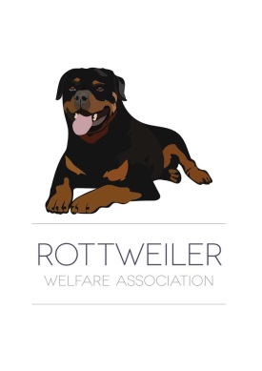
ROTTWEILER WELFARE ASSOCIATION
Registered Charity No 279 478-R
www.rottweilerwelfare.co.uk
Email: enquiries@rottweilerwelfare.co.uk Tel 07946083070

Gift Aid Declaration

Please treat as Gift Aid donations all qualifying gifts of money made

Today

In the past 4 years

In the future

Please tick all boxes you wish to apply.

I confirm I have paid or will pay an amount of Income Tax and/or Capital Gains Tax for each tax year
(6 April to 5 April) that is at least equal to the amount of tax that all the charities that I donate to will reclaim on my gifts for that tax year. I understand that other taxes such as VAT and Council Tax do not qualify. I understand the charity will reclaim 28p of tax on every £1 that I gave up to 5 April 2008 and will reclaim 25p of tax on every £1 that I give on or after 6 April 2008.

Donor’s details

Title ______________ First name or initial(s) _______________________________

Surname _______________________________________________________________

Full home address ________________________________________________________

_______________________________________________________________________

Postcode __________________________________ Date _______________________

Signature _______________________________________________________________

Please notify the charity if you:
- Want to cancel this declaration.
- Change your name or home address.
- No longer pay sufficient tax on your income and/or capital gains.
If you pay Income Tax at the higher or additional rate and want to receive the additional tax relief due to you, you must include all your Gift Aid donations on your Self Assessment tax return or ask HM Revenue and Customs to adjust your tax code.

Please return this form to: Rottweiler Welfare Association PO Box 2424, Wrexham, LL11 0PR

